From: <https://tomluongo.me/2021/06/18/john-stewart-does-davos/>

See also: <https://www.zerohedge.com/geopolitical/why-davos-elites-just-played-jon-stewart-card>

**From the Notebook – Jon Stewart Does Davos**

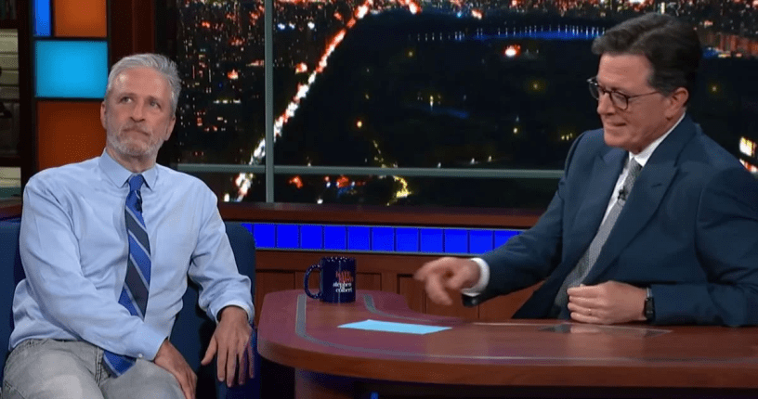

**Date:**[**June 18, 2021**](https://tomluongo.me/2021/06/18/john-stewart-does-davos/)**Author:**[**Tom Luongo**](https://tomluongo.me/author/tfl1728/)[**8 Comments**](https://tomluongo.me/2021/06/18/john-stewart-does-davos/#comments)

*From the Notebook posts are expansions of ideas first published for my Patrons.*[*This one was published on June 15th.*](https://www.patreon.com/posts/52528657)

Jon Stewart is the High Priest of Barely Functional Millennials. Not all Millennials, just the ones he’s personally destroyed. I’ve hated him from the moment my younger friends/family told me they got their news from him rather than you know, the news.

And saying this is not an endorsement of the news, then or now.

Stewart’s [agitprop](https://www.google.com/search?q=agitprop&oq=agitprop&aqs=chrome..69i57.3845j0j15&sourceid=chrome&ie=UTF-8) was the stuff of legend during his run on *The Daily Show*. He programmed an entire generation to think

1. he was the truth-telling court jester when
2. he was really always *The Davos Crowd’s*Pied Piper.

All he had to do was bust open a few easily-busted lies while mugging for the camera.

That’s instant credibility with a generation incapable of real critical thinking.

He was funny when he got his first break on [*Dennis Miller*](https://en.wikipedia.org/wiki/Dennis_Miller) *Live* on HBO back in the early 90’s. I didn’t have cable back then and had a co-worker tape them for me. Jon Stewart stood out. He’s a talented guy, always has been. I don’t begrudge him his talent. It’s one of the hallmarks of evil people, most of them are admirably talented at something.

I also remember back then Miller was a leftie, especially him trying to desperately pin down Charlton Heston on gun control. He (Miller) was outmatched by Chuck/Charlton .

Dennis Miller tapped brilliantly into the Gen-X iconoclasm of the time. He was our high priest of irony. He was also smart in a way that didn’t give a damn whether you got the reference or not.

Can’t keep up, Cha-chi? Go melt some Ice-9 in a Sanka to chill out on Harvey Weinstein’s casting couch while jerking off to reruns of I Dream of Jeannie while getting ready for your closeup.

“Stop me before I sub-reference…. again.” *Classic Miller.*

My hatred for Stewart is nearly two decades old now. And the comparison to Miller should be clear. Stewart took *The Daily Show* and did Miller’s SNL’s Weekend Update routine and subverted the meta-narrative of fake news to steadfastly promote a very particular establishment point of view.

**Democrats smart and good, Republicans stupid and bad.**

He used that Gen-X iconoclasm and his prodigious talent to imprint the impressionable. Meanwhile Gen-X grew up. They grew out of their punk/post-punk adolescence and got more cynical, a lot more cynical. Stewart became a joke. **Miller grew up too, shedding his Boomer roots, and was excommunicated for it.**

At least today he(Stewart)’s still funny, if only as an avuncular crazy uncle version of himself rather than the razor sharp wit he once was.

Stewart faked cynicism and just became more partisan after he’d sunk the tap into the vein deep enough to do the whole body [adrenochrome](https://en.wikipedia.org/wiki/Adrenochrome#In_popular_culture) transfusion. But **he knew exactly what he was doing and had the chops to pull it off.** His partner in thought crime, Stephen Colbert, was only truly ever funny when he was doing voice work for the Adult Swim guys on [Harvey Birdman, Attorney at Law.](https://www.imdb.com/title/tt0294097/)

And that was all the more apparent when Stewart went on Colbert’s late show recently to declare to the world he now believed in the lab-leak origin story of COVID-19 and Colbert tried [or appeared to try] so hard to rein him in.

Peter Spiliakos, [writing for the National Review](https://www.nationalreview.com/corner/the-breaking-of-stephen-colbert/), thinks this is because Colbert didn’t know when to leave the scene and has been ground down by the vocal minority of the Loony Left.

*In the wider America, the*[*vast majority*](https://morningconsult.com/2021/06/09/coronavirus-lab-leak-wuhan-china-poll/)*either believe in the lab-leak theory or are agnostic on the subject. But for the Very Online Left, the lab-leak theory isn’t about true or false. It’s about in-group vs. out-group, and anyone who volunteers that the lab-leak theory might be true is part of the out-group.*

It’s a nice theory, but I think it’s deeper than that. Colbert just isn’t that funny and lives in real fear of everyone figuring that out. He couldn’t hack it if he actually had to appeal to an audience that wasn’t as much of a sanctimonious prick as he is.

When Stewart left the scene and handed the reins to the inept Trevor Noah, there was no hope for the show because Noah, unlike Stewart, doesn’t know where the act begins and the lie ends. When you’ve only grown up with fake irony, fake outrage, how are you supposed to keep things straight when you don’t know where the line is drawn?

**Stewart and Colbert told an entire generation that comedy can only be valid IF it takes a side in the culture war.**

And the net result was far more damaging than even what our pathetic media did then and still does today.

Because humor and iconoclasm are meant to be the foils to the self-seriousness of the establishment.  It’s not supposed to **be** the establishment. The jester is supposed to be the only guy who can tell the truth, because he’s the lowest of the low.

And *The Daily Show,*on Comedy Central **was supposed to be** the antipode to 60 Minutes and Nightline, the kings of news.  **So, what Stewart did, becoming a literal mouthpiece of DNC talking points, practically becoming a member of the DNC itself, is doubly egregious.**

For years I said if I could fight one person I’d fight Milton Friedman because he perverted liberty into neo-slavery economics through advocating for a floating fiat currency standard, our current hell.

I’m revising that and saying I’d fight John Stewart, because 1) he’s alive and 2) he’s pure evil.  His is the charismatic face designed to sell-out an entire generation so that they have no escape route, no counter culture.

Stewart is the opposite of Lenny Bruce, George Carlin, and Richard Pryor.  He’s not going to jail for being subversive, he’s the one telling us we should be in jail for not [towing](https://en.wikipedia.org/wiki/Talk%3AToe_the_line) the party line.

He’s the guy who led the way to political correctness as orthodoxy by setting the table for the rest of the shitlibs to enforce after he left the scene. And here we are today.

Does anyone actually think Trevor Noah is funny? Talented? Really?

Now Stewart comes out at this moment to pull his schtick on Colbert’s show to rally the libs to [the whole WuFlu, “China Did It To Us” Narrative *The Davos Crowd* is pushing on us now?](https://tomluongo.me/2021/06/02/fauci-files-wuflu-war-to-come/)

If you squint hard enough you can see where they missed editing out the puppet strings in the video feed.

They’ve pulled out the John Stewart card to convince the squishy Millennials that China is our enemy.  Google will now whitewash all references to Ft. Detrick, their October 2019 exercises and all the rest of it.  Remember, Millennials, in general, don’t know anything.  They just Google shit and think they’re informed.

John Stewart is the foundation on which their basic lack of inquisition is built on while at the same time telling them they are cynical and informed.  [That’s why the cognitive dissonance over this was so thorough.](https://www.zerohedge.com/political/jon-stewart-hijacks-colbert-show-lab-leak-rant-liberal-twitter-explodes) They now have to side with the evil Republicans and Trumptards over the ‘China Virus’ because John Stewart told them so.

It’s as predictable as it is pathetic.

I don’t want to go off on a rant here, but it’s clear that *Davos* is burning bridges left and right, they are accelerating their plans and calling in all the markers.  They are burning their accumulated political capital very quickly because they now realize they have a little more than a year to do all the damage they are going to do.

There will be political surprises all across Europe this year and next.  By the time they are done the Democrats will look like Labour in the UK, a brittle shell of a party built on equal parts envy and smarm, and the Republicans, guided by Trump, will return to power with a vengeance we’ve never experienced in U.S. politics.  It will not be pretty.

And if John Stewart had any effect the other day he will be one of the reasons why this plan will work. If it doesn’t work then James Cameron better stop working on those Avatar sequels and begin development of Titanic 2: Zombie Boogaflu.

Then again, by the time it comes out it’ll be more Ken Burns than Kurosawa anyway.

Because the goal of this little theatrical display is nothing less than the reunification of the broken American electorate. Both Left and Right, animated by the virus of American exceptionalism, will need someone to blame for the tragedies of today and the hardships of tomorrow.

That’s the script anyhow. It’s what passes for good writing these days in Commie-wood.

If Chinese Premier Xi Jinping is smart he will not take advantage of the paralysis and vacuum at the top of the U.S. political system as led by the Olden Girls and make a move on Taiwan.  He should just do nothing and let *Davos’*plans to get the two countries to fight fall flat.  That would honestly be the best possible outcome at this point.

The good news is Stewart’s curtain call was a bit too much needle scratch and not enough Honest Injun. The bad news is that most of the people he was targeting can’t tell the difference.

And even if they do see through his schtick that just leaves us even more angry and divided than before while

1. Nancy Pelosi forces struggle sessions over Juneteenth in Congress,
2. organizing election fraud in Georgia may get Stacey Abrams the Nobel Peace Prize and
3. the government is trying to make the X-Files a documentary.

Ah, fuck it, who wants pie?!

[Join my Patreon](http://www.patreon.com/goldgoatsnguns) if you’re more [Dennis] Miller than [Jon] Stewart